This is a fairly easy and convenient way to set up the Lopy as a NanoGateway.

1.Make sure the firmware is updated, just begin here even if you think the firmware is updated. Place the connection btw G23 and GND then update the firmware using the PyComm Firmware Updater software.

2.Next, flash the whole system to remove any files that may have been there and restore it back to the original settings. Use the following commands on the REPL prompt

import os

os.mkfs('/flash')

Now soft reset(restart) the Lopy using the following commands

import machine

machine.reset()

Just to be sure everything is fine, run the following code

from network import WLAN

wlan = WLAN() # we call the constructor without params

print(wlan.ifconfig())

The IP address printed by the print function should be 0.0.0.0, meaning you have a clean slate!

Now clone the repo at <https://github.com/wechuli/iot-projects.git> if you have not already

There are two convenient files in the parent directory of the setting-up-lora-nano-gateway folder .one is called mac.py and the other wifi.py.

Am assuming you already have Atom installed and the Pymkr plugin also running (otherwise how did you even get to this point of the tutorial since the first parts require you to run commands on the REPL which you could not without having installed Atom and Pymkr.) Open the parent directory in Atom.

Open the mac.py file. The LoPy should be connected. Press run. This file gives you the Mac address of your LoPy, details you will use to register the LoPy at TTN.

The other file in the parent directory is wifi.py. Run this file also, make sure to change the Wi-Fi ssid and password in it before running it ….dah. After changing the Wi-Fi ssid and password press CTRL-S to make sure Atom saves the changes. This enables you to upload files to your LoPy using FileZilla. Note this address down, you should connect your computer to the same network as the LoPy, otherwise how in the world were you expecting to upload the files to it using FileZilla

In the repo you cloned, there is a folder called LoraGateway. Here you will find 4 files. You only need to touch one file here, that is the config.py file. Touch the others at your own peril. In the config.py file, change gateway id to reflect the one you registered in TTN (when registering the gateway at ttn make sure to choose ‘packet-forwader’ otherwise it will not work). Also change the ssid and password to those of your network.

Next, connect using File Zilla, follow the instructions below. The user is ‘micro’ and the password in ‘python’ , without the quotes of course.

**FileZilla**

If using FileZilla, it's important to configure the settings correctly.

Do not use the quick connect button. Instead, open the site manager and create a new configuration. Within the General tab, ensure that encryption is set to: Only use plain FTP (insecure).

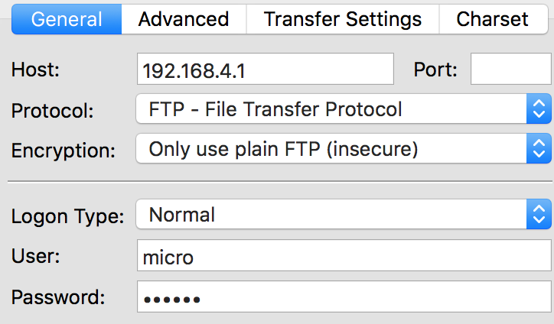

In the Transfer Settings tab, limit the max number of connections to one. Other FTP clients may behave in a similar ways; visit their documentation for more specific information.

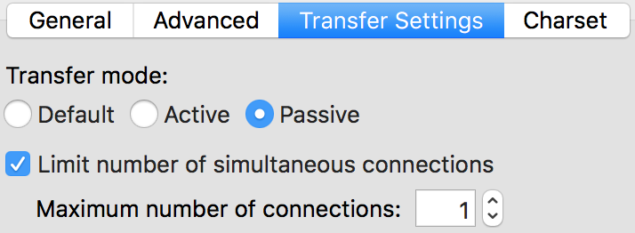

Open the /flash folder. On the side of your computer navigate to the parent folder of the repo you cloned, open the gateway folder. You have 4 files here main.py,boot.py,config.py,nanogateway.py. Select them all and drag them inside the /flash folder of the LoPy. Accept if it asks you to replace existing main.py and boot.py folders.

Now repeat the soft reset command

import machine

machine.reset()

Open the REPL terminal in Atom. The LopY should connect to the Wi-Fi and begin sending ack packets to TTN and you should see it connected on your TTN console even if it is not uploading actual packets from a node.

If it didn’t work, try repeating the procedure above. If you’re still stuck, maybe these things are not for you. You probably have better things to do with your time. ☺.